WEAR IT: A COLLABORATIVE
E-COMMERCE STORE

PROJECT REPORT

Submitted to
UNIVERSITY OF CALICUT
In partial Fulfilment of the requirements of the award for the degree of

BACHELOR OF SCIENCE
IN
COMPUTER SCIENCE (2021-2024)

Submitted by

ASLAHA P.V (RegNo: ZEAVSCS001)
NADEEM MUHAMMED HANEEFA A.K (RegNo: ZEAVSCS008)
SHIBLA P.S (RegNo: ZEAVSCS021)
MUHAMMED SUHAIL T.M (RegNo: ZEAVSCS034)

Under the Guidance of
Mrs ANCY T.A
(Assistant Professor –Department of Computer Science)



NAAC Accredited with B+ Grade

Mele-Pattambi, 679306, Palakkad
DEPARTMENT OF COMPUTER SCIENCE AND

APPLICATIONS

LE-MENT COLLEGE OF ADVANCED STUDIES

(Affiliated to University of Calicut)
NAAC Accredited with B+ grade


CERTIFICATE

This is to certify that the project work entitled
WEAR IT: A COLLABORATIVE
E-COMMERCE STORE

Is the bonafide record of work done by

ASLAHA P.V ZEAVSCS001
NADEEM MUHAMMED HANEEFA A.K ZEAVSCS008
SHIBLA P.S ZEAVSCS021
MUHAMMED SUHAIL T.M ZEAVSCS034

Mrs Rahna Hamza K.V Mrs Ancy T.A
Head of the Department Faculty Guide

Submitted for the Viva-Voce Examination held on……………………………………….

INTERNAL EXAMINAR EXTERNAL EXAMINAR
1.

2.
DECLARATION

We hereby declare that the project report entitled “WEAR IT: A COLLABORATIVE
E-COMMERCE STORE” done as the partial fulfilment of the requirements for the award of the degree of Bachelor of Science (B.sc COMPUTER SCIENCE), is a project report done by us during the duration of our period of study in Sixth Semester in Le-Ment College of Advanced Studies, Pattambi under the guidance of Mrs Ancy T.A Assistant professor of computer science and this has not been previously submitted for the award of Degree in this and other colleges or Universities.

Signature of Students
ASLAHA P.V (ZEAVSCS001):________________________________________

NADEEM MUHAMMED HANEEFA A.K (ZEAVSCS008):_________________

SHIBLA P.S (ZEAVSCS021):_________________________________________

MUHAMMED SUHAIL T.M (ZEAVSCS034):___________________________

Counter Signed by the Guide
Place:
Date:

ACKNOWLEDGEMENT

We are grateful to each and every one who has contributed numerous ways in the development of this project whose efforts have been a healing hand in every footstep towards our destiny.
We give all the glory and honour to the God Almighty, whose divine touch had been the foremost inspiration and guiding light in the fulfilment of this uphill task.
We glad to present the project report entitled “WEAR IT: A COLLABORATIVE
E-COMMERCE STORE” prepared as a part of our Sixth Semester, BSC Computer Science program.

We take this opportunity to express our deep sense of gratitude and sincere thanks to our Principal Mr SHABEER K.P of Le-Ment College of Advanced studies for giving us an opportunity to take up the project work.

We place on record our Internal Guide Mrs ANCY T.A faculty of the Computer Science department her guidance for smooth completion of this project. Without her determination and enthusiasm this project would be incomplete.
We extend our sincere gratitude to all other staff members of the computer science department, who have contributed to complete this project.
We are extremely grateful to our parents for their moral support and continuous encouragement, which has always been a source of inspiration to us.

We also express our heartfelt thanks to our dear friends who had supported us in our endeavour to complete this project successfully.

ABSTRACT

Our innovative solution aims to revolutionize the way we shop for clothes brand providing a collaborative e-commerce platform for clothing stores. Our platform offers a one-of-a-kind shopping experience that allows customers to easily browse and purchase products from multiple stores in one convenient place. In this project, we will showcase the features and benefits of our solution. Our platform enables stores to effortlessly list their products, providing customers with a seamless shopping experience. Moreover, our platform offers analytics and insights to help stores optimize their sales and marketing strategies, and ultimately increase their revenue. Our platform also offers a unique Market area for small-scale fashion businesses. This area allows them to showcase their products to a wider audience, increase their sales, and take their business to new heights. By leveraging the potential of an e-commerce website, our goal is to empower small-scale fashion businesses and help them reach their full potential. By utilizing the advertisement section, sellers can take their products to new heights and expand their reach beyond their expectations. The system also empowers users to discover the best products based on their needs and preferences, leading to a more personalized and fulfilling shopping experience. The system has three modules User, Admin and Seller. The main distinction is that they don't have to own space, they can look for all the products by staying home, and also do purchases from home. Also your consumer base isn't restricted to a single geographic location or region. This becomes the added benefit of going online. You do the same things on an ecommerce website as well as in shops. Here we using flutter as frontend. And PHP as backend.

TABLE OF CONTENTS

Chapter Page No

- Introduction…………………………………………………….………01
1.1 Objectives…………………………………………………………………………
- Software Configuration…………………………………………………
2.1 Hardware Requirement…………………………………………………………….
2.2 Software Requirements…………………………………………………..……….
- System Development and Analysis…………………………………….
3.1 Existing System………………………………………………………………….
3.2 Proposal System………………………………………………………………….
- Literature Survey……………………………………………………….
4.1 Feasibility Study………………………………………………………………….
4.1 Technical Feasibility……………………………………………………………..
4.3 Economical Feasibility………………………………………………………….
4.4 Operational Feasibility……………………………………………………………
4.5 Legal Feasibility………………………………………………………………….
4.6 Schedule Feasibility……………………………………………………………….
4.7 Resource Feasibility ………………………………………………………………
- System Design and Development………………………………………
5.1 Design Process……………………………………………………………………
5.2 Notation used in DFD……………………………………………………………
5.2.1 Data Flow Diagram…………………………………………………………….
5.3 Table Design……………………………………………………………………...
5.4 ER Diagram………………………………………………………………………
- Implementation…………………………………………………….......
6.1 Implementation Method………………………………………………………….
6.2 Implementation Plan……………………………………………………………..
6.3 Code………………………………………………………………………………

6.4 App Screenshot…………………………………………………………………………
- Conclusion………………………………………………………………….
- Scope of Future Work…………………………………………………….
- Bibliography……………………………...................................................
LIST OF FIGURES

Figure Page No

Figure1: Data flow Diagram………………………………………………………….
Figure2: Data Flow Diagram for Admin…………………………………………….
Figure3: Data Flow Diagram for Seller……………………………………………….
Figure4: Data Flow Diagram for User…………………………………………………
Figure5: User Table………………………………………………………………....…
Figure6: Order Table……………………………………………………………………
Figure7: Item Table………………………………………………………………….....
Figure8: Cart Table……………………………………………………………………..
Figure9: Feedback Table………………………………………………………………..
Figure10: Survey Table………………………………………………………………….
Figure11: ER Diagram………………………………………………………………….

1. INTRODUCTION

Revolutionizing E-Commerce is a crucial step towards bringing together clothing stores and online retailing. With this innovative solution, we aim to provide a collaborative platform for clothing stores to reach a wider audience. The solution will enable customers to browse and purchase products from multiple stores in one place. It is becoming increasingly relevant in transforming how consumers purchase goods and services. This system can be a traditional sales system where sellers meet with consumers face to face. Traditional methods enable the customer to recognize products to obtain consumer satisfaction. However, this approach has the disadvantage of being a waste of time. E-Commerce makes shopping more accessible than it is now. Users, for instance, can buy multiple products with only one click of the "Order" button. Despite its rising popularity, e-commerce has a market limitation, and no one can help shoppers in online stores. Online retailers have numerous features, such as a search and directory, to assist customers in addressing this limitation. Our solution provides a collaborative online retailing platform for clothing stores. This platform also offers a unique Market area for small-scale fashion businesses. The platform will enable stores to list their products and reach a wider audience. Customers will be able to browse and purchase products from multiple stores in one place, making the shopping experience more convenient. Additionally, the platform will provide analytics and insights to help stores optimize their sales and marketing strategies. Objectives of this offers several benefits for both clothing stores and customers. Stores will be able to reach a wider audience and increase their sales. Customers will have access to a wider variety of products and a more convenient shopping experience. Overall, our solution aims to revolutionize the e- commerce industry and bring together clothing stores and online retailing. The project aims to tap into this market by providing a unique and innovative platform for clothing stores to reach a wider audience. It offers a unique and innovative platform for clothing stores to reach a wider audience and compete in the e-commerce industry. With the rise of online shopping, it is crucial for clothing stores to adapt and embrace new technologies. Objectives of this app is revolutionize the e-commerce industry and bring together clothing stores and online retailing.

1.1 Objectives

This application offers a range of benefits including a seamless and intuitive shopping experience for users, facilitating easy navigation, quick access to product information, and secure payment processing. Improved brand recognition, enhanced marketing communications, increased efficiency, affordable advertising and marketing, easy product and price comparison, faster purchasing process, location- based targeting, an established market area for small industries, and multiple stores conveniently located in one place. Furthermore, it seeks to optimize backend operations, such as inventory management and order fulfillment, to ensure timely delivery and customer satisfaction. Overall, the primary goals revolve around driving sales, fostering customer loyalty, and maximizing operational efficiency to establish a successful online retail presence.

2. SOFTWARE CONFIGURATION

2.1 Hardware Requirements
  - OS: Android 9 or above

- Processor: Snapdragon or Exynos and Mediatek

- Ram: 4 or above

- Rom: 32 or above

2.2 Software Requirements

  - Processor: i3 or Above

- OS: Windows 8 or above

- Frontend: Flutter

- Backend: PHP

- Database: My Sql

- Tools Used: VS code, Android Studio

3. SYSTEM DEVELOPMENT AND ANALYSIS

3.1: Existing System

The existing system of our ecommerce app for clothing incorporates a user-friendly interface that allows customers to browse through a wide range of clothing items conveniently. The app features various categories and filters to streamline the shopping experience, along with detailed product descriptions and images to help users make informed decisions. It includes secure payment gateways to ensure transactions are safe and reliable. Additionally, the app offers personalized recommendations based on user preferences and browsing history to enhance customer engagement and satisfaction. Customer support is readily available through multiple channels to address any queries or concerns promptly. Overall, the existing system aims to provide a seamless and enjoyable shopping experience for clothing enthusiasts.

3.2: Proposed System

Our platform is aimed at enabling clothing stores to enhance their e-commerce capabilities through collaboration. By using our tool, stores can effortlessly list their products and offer customers a smooth shopping experience. The analytic features also help to optimize sales and marketing strategies. Moreover, small-scale fashion businesses can take advantage of the Market section to showcase their products and increase visibility. Customers can also use our platform to locate all available shops in their current location and purchase products from their preferred stores. The system also empowers users to discover the best products based on their needs and preferences, leading to a more personalized and fulfilling shopping experience. Ultimately, our goal is to empower small-scale fashion businesses through e-commerce.

4. LITERATURE SURVEY

4.1 Feasibility Study

A feasibility study is an evaluation of a proposal designed to determine the difficulty in carrying out a designed task. Generally, a feasibility study precedes technical development and project implementation. In other words, a feasibility study is an evaluation or analysis of the potential impact of a proposed project. Feasibility Study is performed to choose the system that meets the performance requirements at least cost. The most essential tasks performed by a Feasibility Study are the identification and description of candidate systems, the evaluation to determine if developing app is visible and worthwhile. The best system means the system that meet performance requirements at the least cost. The most difficult part of a Feasibility Study is the identification of the candidate systems and the evaluation of their performances and costs. The new system has no additional expense to implement the system. The new system has advantages such as we can easily access files from any client in the Network, accurate output for accurate input and this application is more user friendly. We can use this application not only in this organization but also in other firms. So it is worth solving the problem.

4.2 Technical Feasibility

The technical feasibility of an ecommerce app involves evaluating factors like technology stack, platform compatibility, scalability, security, and integration capabilities. It assesses whether the required technology infrastructure can be implemented effectively to support the app's functionality and performance requirements within budget and time constraints. Additionally, considerations for backend infrastructure, database management, payment gateway integration, and user experience optimization are crucial in determining the technical feasibility of the project.

4.3 Economical Feasibility

Assessing the economic feasibility of an ecommerce app involves considering factors like development costs, potential revenue streams (such as sales commissions, subscription fees, or advertising), market demand, competition, and on-going operational expenses like maintenance and marketing. Conducting a thorough cost- benefit analysis can help determine whether the projected returns justify the initial investment. Additionally, factors like scalability and long-term sustainability should be taken into account.

4.4 Operational Feasibility
Operational Feasibility study is performed to check whether the system is operationally feasible or not. Using command buttons throughout the application programs enhances operational feasibility. So maintenance and modification is found to be easier. However, challenges like cyber security risks, logistics management, and maintaining customer trust require careful consideration and strategies planning.
4.5 Legal Feasibility

Determines whether the proposed system conflicts with legal requirements or not. e.g.: A data processing system must comply with the local Data Protection Acts.

4.6 Schedule Feasibility

A project will fail if it takes too long to be completed before it is useful. Typically this means estimating how long the system will take to develop, and if it can be completed in a given time period using some methods like payback period. Schedule feasibility is a measure of how reasonable the project timetable is.

4.7 Resource Feasibility

This involves questions such as how much time is available to build the new system, when it can be built, whether it interferes with normal business operations, type and amount of resources required, dependencies, etc. Contingency and mitigation plans should also be stated here.

5. SYSTEM DESIGN AND DEVELOPMENT

The most creative and challenging phase of the life cycle is system design. The term design describes a final system and the process by which it developed. It refers to the technical specifications that will be applied in implementations of the candidate system. The design may be defined as "the process of applying various techniques and principles for the purpose of defining a device, a process or a system with sufficient details to permit its physical realization".

The designer's goal is how the output is to be produced and in what format. Samples of the output and input are also presented. Second input data and database files have to be designed to meet the requirements of the proposed output. The processing phases are handled through the program Construction and Testing. Finally, details related to justification of the system and an estimate of the impact of the candidate system on the user and the organization are documented and evaluated by management as a step toward implementation. The importance of software design can be stated in a single word "Quality". Design provides us with representations of software that can be assessed for quality. Design is the only way where we can accurately translate a customer's requirements into a complete software product or system. Without design we risk building an unstable system that might fail if small changes are made. It may as well be difficult to test, or could be one who's quality can't be tested. So it is an essential phase in the development of a software product.

5.1 Design Process

Designing an e-commerce app involves several crucial steps to ensure a seamless user experience and efficient functionality. The process typically begins with thorough research and planning, where understanding the target audience, market trends, and competitors' offerings is essential. Next, wire framing and prototyping help visualize the app's layout, navigation flow, and features before actual development begins. User interface (UI) and user experience (UX) design play a pivotal role in creating intuitive interfaces, clear product categorization, smooth checkout processes, and engaging interactions to enhance customer satisfaction and retention. Concurrently, backend development focuses on implementing secure payment gateways, robust database management, inventory tracking, and order processing systems. Integrating analytics tools enables monitoring user behaviour and performance metrics to iterate and improve the app continuously. Rigorous testing, including functionality, usability, security, and compatibility checks across different devices and platforms, ensures a bug-free and reliable application. Finally, deploying the app to app stores and deploying marketing strategies to drive user acquisition and engagement completes the design process, followed by on-going maintenance and updates to adapt to evolving market demands and technology advancements.

Normalization of Database

Database Normalization is a technique of organizing the data in the database. Normalization is a systematic approach of decomposing tables to eliminate data redundancy (repetition) and undesirable characteristics like Insertion, Update and Deletion Anomalies. It is a multi-step process that puts data into tabular form, removing duplicated data from the relation tables. Normalization is used for mainly two Normalization rules are divided into the following normal forms:

- First Normal Form
- Second Normal Form
- Third Normal Form
- BCNF

First Normal Form:

Eliminate duplicate columns from the same table. Create separate tables for each group of related data and identify a primary key for each table. Ensure that each column contains atomic values (no multi-valued attributes).

Second Normal Form:

Meet all the requirements of 1NF. Remove partial dependencies by separating subsets of data that apply to multiple rows in a table into separate tables. Ensure that non-key attributes are fully dependent on the primary key.In this application we are using second normal form.
List of Modules

- Admin: A centralized dashboard for administrators to view key metrics, such as sales, revenue, inventory levels, and user activity. Admins can manage user accounts, including registration, authentication, and permissions. Ability to add, edit, and delete products, manage categories, set prices, and update inventory.

- Seller: Sellers can add new products, update existing ones, set prices, manage inventory and categorize products. View and manage orders placed for their products, update order status, manage shipping, and generate invoices.

- User: Users can register, log in, and manage their accounts securely. Browse products by category, search for specific items, and filter products based on various criteria. View detailed product descriptions, images, prices, ratings, and reviews.

About the Tools

In this project, I am started with the web based application. To do that initially we choose the programming language as Flutter based Desktop application, front end is made with Flutter and for the back end is PHP. Database layer MySQL. I have used responsive design method for developing User Interface, which is adaptable for any Viewport.

Flutter

Flutter is an open-source UI software development toolkit created by Google, designed to help developers build natively compiled applications for mobile, web, and desktop from a single codebase. Launched in 2017, Flutter has gained significant popularity for its fast development speed, expressive and flexible UI, and ability to create visually appealing applications. One of Flutter's key features is its use of the Dart programming language, which allows developers to write code that can be compiled to native ARM code for optimal performance. The framework also provides a rich set of pre-designed widgets, facilitating the creation of consistent and visually appealing user interfaces across different platforms. Flutter's hot reload feature allows developers to instantly see the impact of their code changes, speeding up the development and debugging process. With its versatility and robust community support, Flutter has become a popular choice for developers aiming to create cross-platform applications efficiently and with a high level of visual fidelity.
Flutter Platform

Flutter is a versatile and cross-platform development framework that allows developers to create applications for various platforms, including mobile, web, and desktop, using a single codebase. The term "Flutter platform" typically refers to the ability of the framework to seamlessly adapt and deploy applications on different operating systems and devices. With Flutter, developers can target iOS and Android for mobile, deploy as a web application, and even extend their reach to desktop platforms like Windows, mac OS, and Linux. This unified development approach streamlines the process of building and maintaining applications, as developers can avoid the need to create separate codebases for each platform. Flutter's platform independence is achieved through its native compilation to machine code, ensuring high performance and a consistent user experience across diverse devices. The framework's adaptability to multiple platforms has made it a popular choice for developers looking to efficiently deliver applications with a consistent look and feel across various devices and operating systems.

PHP

PHP, which stands for Hypertext Pre-processor, is a widely-used server-side scripting language designed for web development. Known for its simplicity, ease of integration, and broad community support, PHP is embedded within HTML code and executed on the server, generating dynamic content that can be sent to the user's browser. PHP supports various databases, making it suitable for developing database-driven web applications. It also boasts a vast ecosystem of libraries and frameworks, such as Laravel and Symfony, that enhance development efficiency and maintainability. Despite some criticisms regarding its syntax and security concerns in the past, PHP has undergone significant improvements with each version release, addressing these issues and contributing to its enduring popularity as a server-side scripting language in the world of web development.

PHP Platform
PHP is a server-side scripting language widely used for web development. It enables the creation of dynamic and interactive web pages by embedding within HTML code. PHP supports various databases, has a large community, and is enhanced by frameworks like Laravel. Despite past criticisms, on-going updates have improved PHP's syntax and security, solidifying its position as a robust platform for building dynamic web applications.

5.2 Notations used in DFD

In Data Flow Diagrams (DFDs) for an E-Commerce app, various symbols and notations are used to represent different elements and relationships within the system. Here are some common notations used in DFDs for E-Commerce applications:

Element Reference Symbol

Process Round (Rectangle)

External Entity (Square)

Data store (open-ended Rectangle)

Data Flow(Arrow)


Data Flow Source/ Destination(oval)
5.2.1 Data Flow Diagram

A data flow diagram (DFD) is a graphical representation of the flow of data through a system. It shows how data moves from input sources to processing and storage, and then to output destinations. In the context of the private bus time and route view system project, a DFD could consist of the following elements:

External entities: These are the actors or entities that interact with the system, such as user, seller, and admin.

Processes: These are the activities that transform the data, such as data validation, calculations, and updates to the database.

Data stores: These are the repositories where data is stored, such as databases or files.

Data flows: These are the paths that data takes as it moves through the system.

1. Level-0-DFD

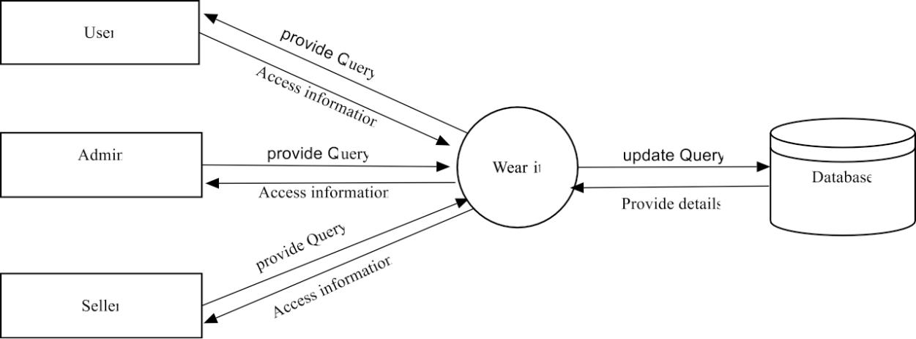

2. Level-1-DFD For Admin

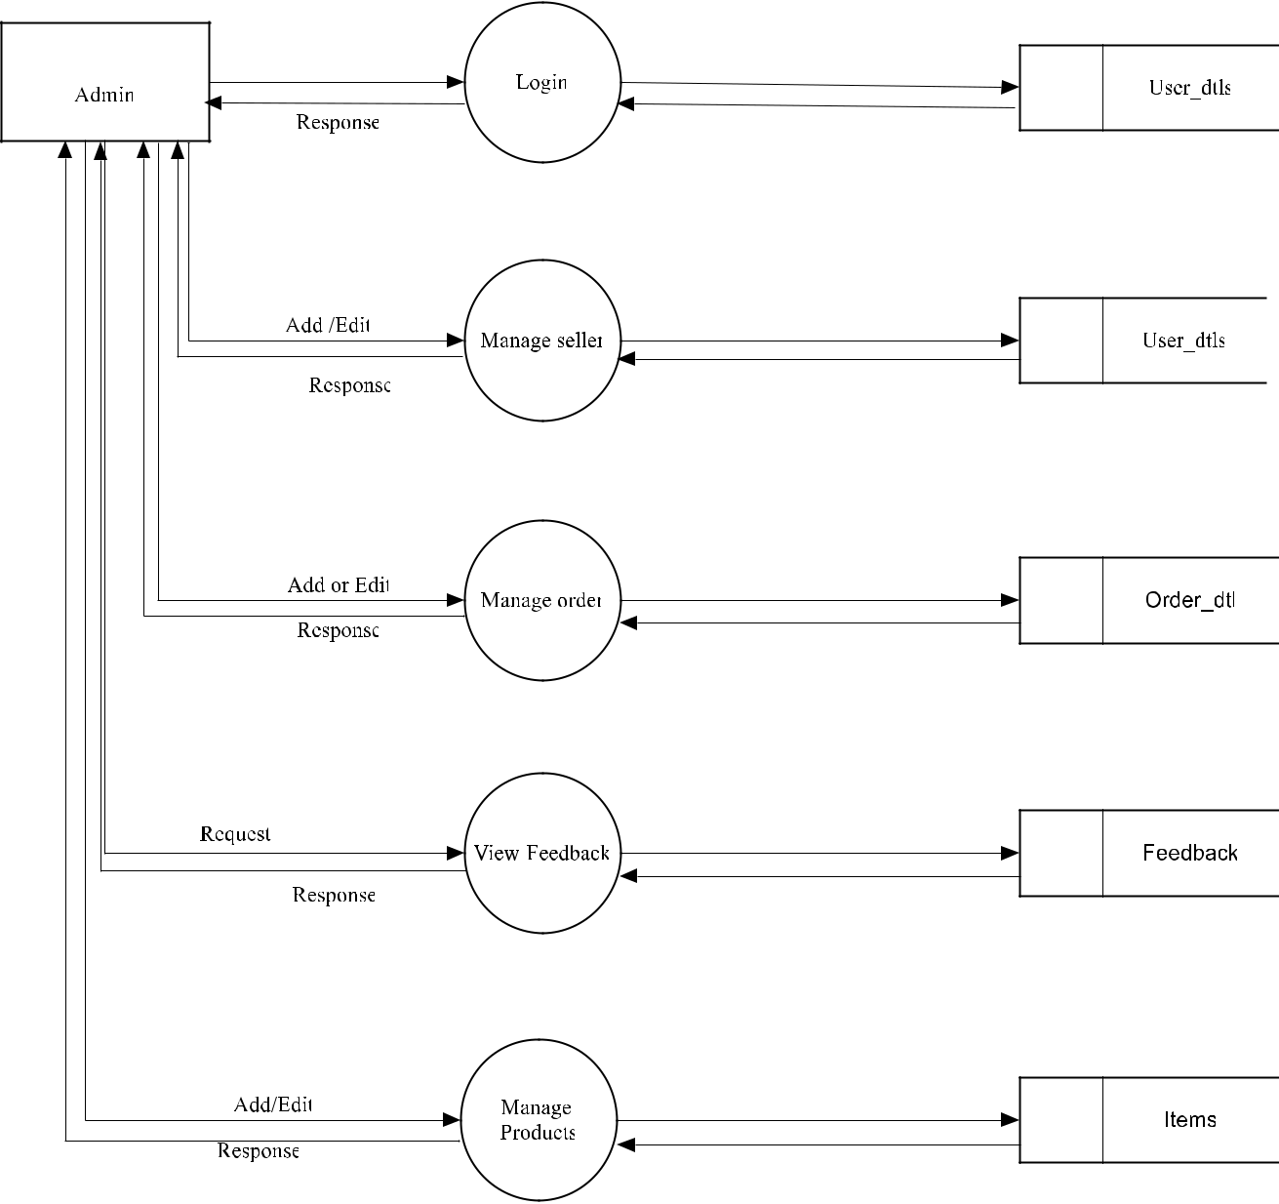

Level-1-DFD for Seller

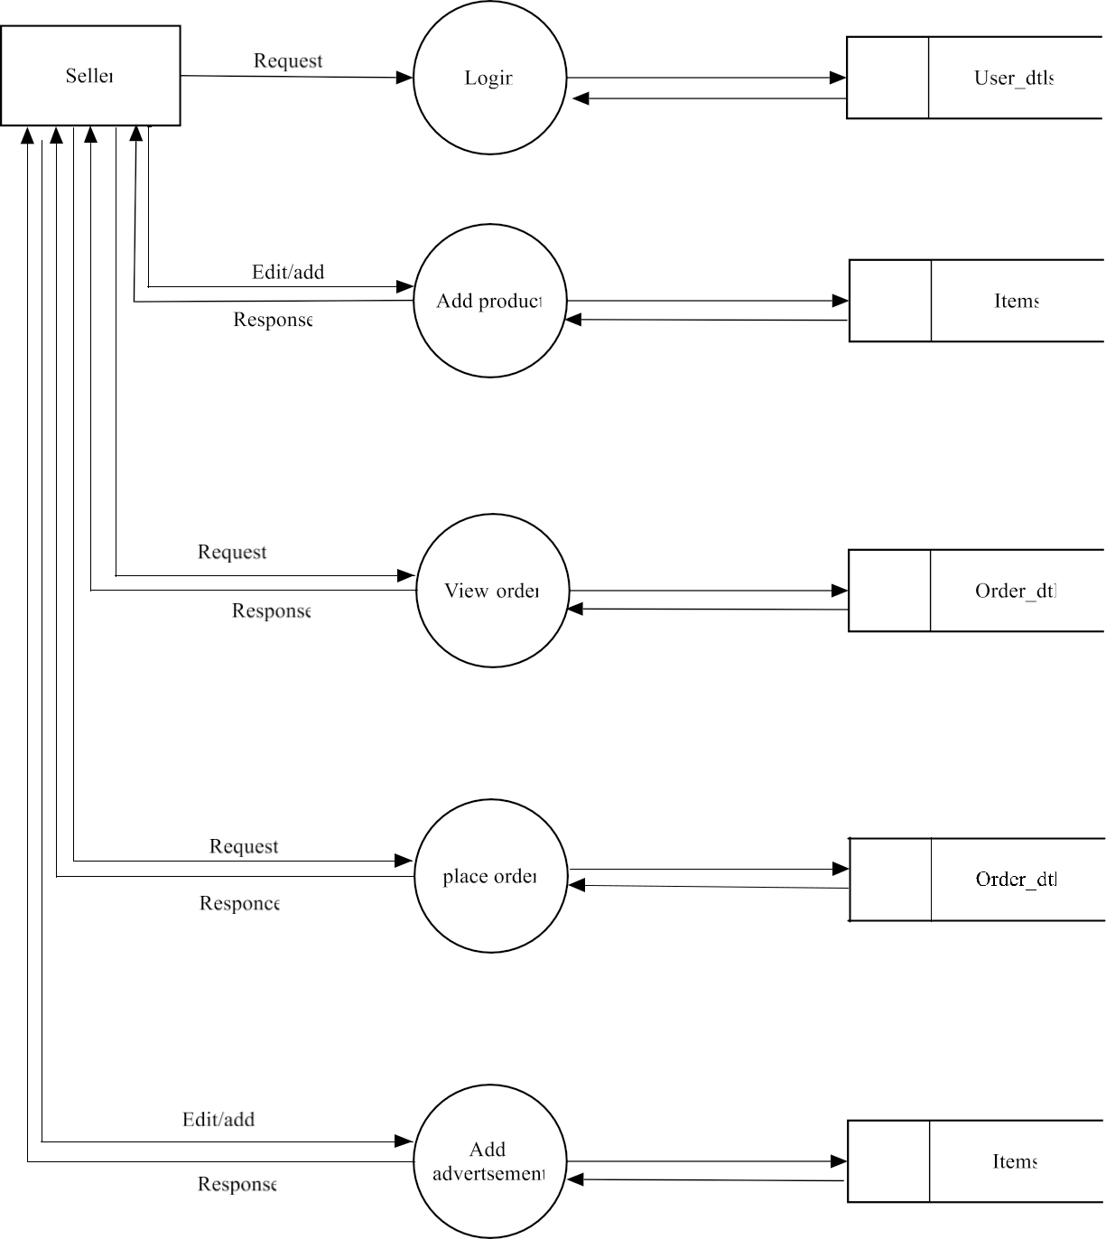

Level-1-DFD for User

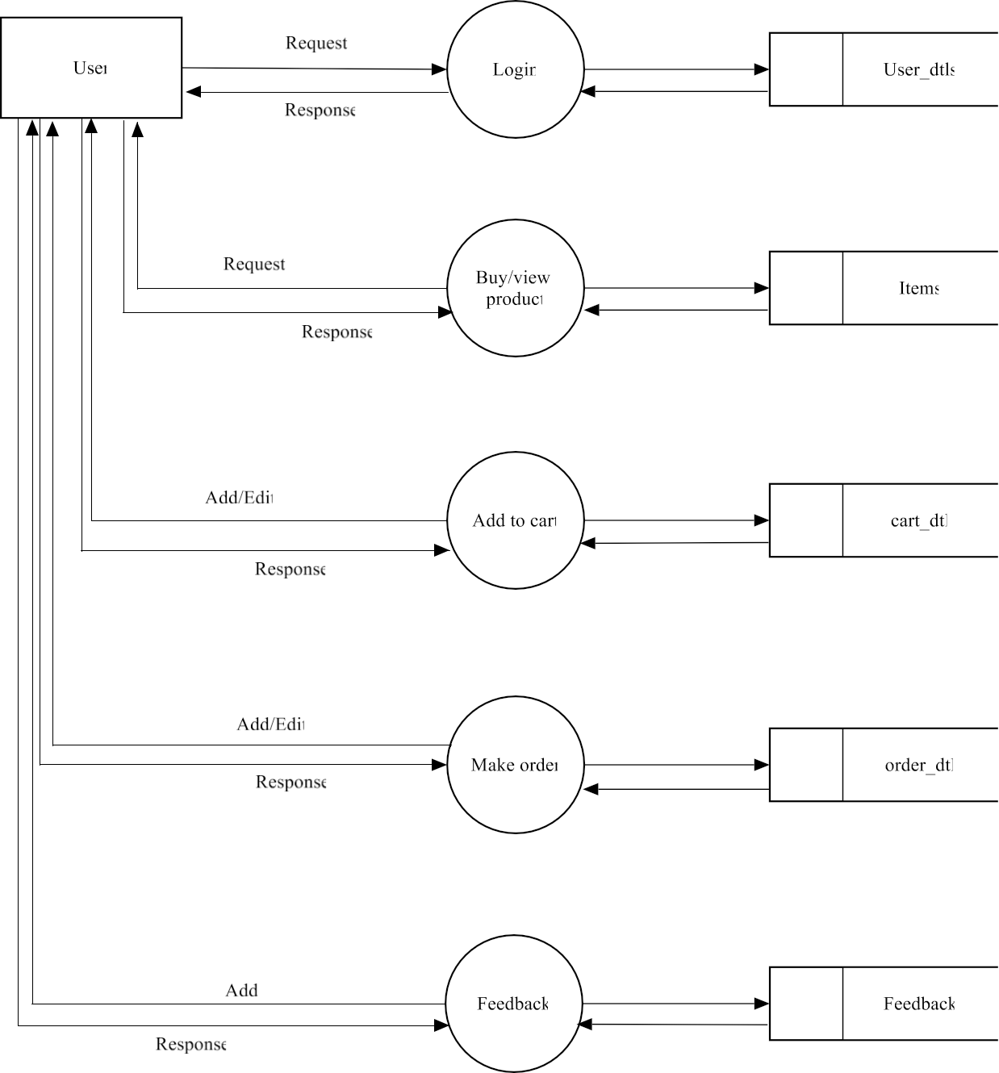

5.3 Table Designs

1. User-Table
Name | Datatype | Constraint
Login id | Int(10) | Primary key
Name | Varchar(50) | Not Null
Password | Varchar(50) | Not Null
Location | Varchar(50) | Not Null
Shop Name | Varchar(50) | Not Null
Image | Varchar(50) | Not Null
Phone | Varchar(20) | Not Null
Address | Varchar(50) | Not Null

2. Order Table
Name | Datatype | Constraint
Id | Int(10) | Primary key
Item id | Int(10) | Foreign key
Quantity | Int(10) | Not Null
Date | Date Time | Not Null
User id | Int(10) | Foreign key
Address | Varchar(100) | Not Null
Amount | Varchar(10) | Not Null
Size | Varchar(10) | Not Null

3. Item table
Name | Datatype | Constraint
Id | Int(11) | Primary key
Item Name | Varchar(50) | Foreign key
Price | Int(10) | Not Null
Seller id | Int(10) | Foreign key
Url | Varchar(500) | Not Null
Review | Int(11) | Not Null
Star | Int(11) | Not Null
Value | Int(11) | Not Null
Category | Varchar(20) | Not Null
Brand | Varchar(20) | Not Null
Trending | Int(10) | Not Null
Advertisement | Int(10) | Not Null

4. Cart table
Name | Datatype | Constraint
Id | Int(10) | Primary key
Item id | Int(10) | Foreign key
Quantity | Int(10) | Not Null
Date | Date time | Not Null
User id | Int(10) | Foreign key
Value | Int(10) | Not Null

5. Feedback Table
Name | Datatype | Constraint
Id | Int(10) | Not Null
Feedback | Varchar(50) | Not Null

6. Survey Table
Name | Datatype | Constraint
User id | Int(50) | Foreign key
Data | Text | Not Null

5.4 Entity –Relationship Diagram

The Entity-Relationship (ER) diagram for an e-Commerce app illustrates the relationships between key entities within the system. The primary entities include User, Product, Category, Order, Order Item, Payment, Cart, Cart Item, and Review. Users can place multiple orders, each associated with a unique order ID, order date, total amount, and status. Each order consists of multiple order items, detailing the purchased products, quantities, and subtotals. Products belong to categories, establishing a many-to-many relationship. Users can leave reviews for products, forming a many-to-many relationship as well. Additionally, users have a cart to which they can add multiple items, forming a one-to-many relationship with cart items.

Each user account is characterized by a user ID, first name, last name, email, password, address, and phone number. Products are identified by a product ID, name, description, price, stock quantity, and a foreign key referencing their associated category. Categories are defined by a category ID and name. Orders have an order ID, user ID, order date, total amount, and status.

Order items are identified by an order item ID, order ID, product ID, quantity, and subtotal. Payments have a payment ID, order ID, payment method, amount, and transaction date. Lastly, reviews are characterized by a review ID, user ID, product ID, rating, comment, and date. This ER diagram provides a comprehensive overview of the entities and their relationships, forming the foundation for developing a robust and well-structured e-Commerce application.

6. IMPLEMENTATION

System implementation is the final phase i.e., putting the utility into action. Implementation is the state in the project where theoretical design turned into working system. The most crucial stage is achieving a new successful system and giving confidence in new system that it will work efficiently and effectively. The system is implemented only after thorough checking is done and if it is found working in according to the specifications. It involves careful planning, investigation of the current system and constraints on implementation, design of methods to achieve. Two checking is done and if it is found working according to the specification, major task of preparing the implementation a reeducating, training the users. The implementation process begins with preparing a plan for the implementation of the system. According to this plan, the activities are to be carried out, discussions made regarding the equipment and resources and the additional equipment has to be acquired to implement the new system. The most important in implementation stage is , gaining the users confidence hat the new system will work and be effective. The system can be implemented only after through testing is done. This method also offers the greatest security since the existing system can take over if the errors are found or inability to handle certain type of transactions while using the new system.

6.1 Implementation Methods

There are several methods for handling the implementation and consists for changing from the old to the new computerized system. The most secure method for conversion from the old system is to run the old and new system in parallel. In this approach ;a person may operate in the manual processing system as well as start operating the new computerized system. Another commonly used method is a direct cut over the existing manual system to the computerized system. The change may be within a week or a day. This strategy requires planning. A working version of the system can also be implemented in one part of the organization and the changes can be made as and when required, but this method is less preference due to the loss of entire system. After the system is Implementation, a review should be conducted to determine whether the system is meeting expecting where improvements are needed.

Implementation is the process of bringing a developed system into operational use and turning it over to the user. Implementation includes all those activities that take place to convert from old system to new. At this stage the theoretical design is turned into a working system. The crucial stage in achieving a successful new system and giving confidence on the system for the users that will work efficiently and effectively.

Implementing an ecommerce app typically involves several key steps:
- Market Research: Understand your target audience, competitors, and market trends.
- Define Requirements: Determine features, functionalities, and technical specifications.
- Choose Technology Stack: Select appropriate platforms, frameworks, and tools based on your requirements and expertise
- Design UI/UX: Create intuitive, user-friendly interfaces for both web and mobile platforms.
- Backend Development: Build robust server-side infrastructure to handle data storage, security, and business
- Frontend Development: Develop responsive and visually appealing client-side interfaces for web and mobile.
- Integration: Integrate payment gateways, shipping APIs, and other third-party services.
- Testing: Perform thorough testing to ensure functionality, performance, and security.
- Deployment: Deploy the app on appropriate hosting platforms and app stores.
- Maintenance: Regularly update, optimize, and enhance the app based on user feedback and technological advancements.
Each step requires careful planning and execution to ensure the success of your ecommerce app.
6.2 Implementation Plan

Implementation plan includes a description of all activities that must occur to implement the new system and to put into operation. It defines the personal responsible for the activities and prepares a time chart for Implementation the system. The Implementation plan should anticipate possible problems and must be able to deal with them. The usual problem may be missing documents ,missed data formats between current and new files, errors in data translation ,missing data etc. Training plats are an important element of the implementation plan. Their purpose is to ensure that all the persons who are associated with the computer based business system possess the necessary knowledge and skills.

Operator training

Operator training is completed in conjunction with its installation and checkout.Operators must become familiar with operational requirements of the new systems.Well prepared manual provide a ready reference to specific duties and step by step operation instruction.

User Training

After the system is implemented successfully, training of the user is one of the most important subtasks of the developer. Even well designed and technically elegant systems can succeed or fail, because of the way they are operated and used. For this purpose user manuals are prepared and handled over to the user to operate the developed system. Thus the users are trained to operate the developed system. Both the hardware and software securities are made to run the developed systems successfully in future. In order to put new application system into use, preparation of user and system documentation, conducting user training with demo, test run for some period to ensure smooth switching over the system are to be prepared.

Documentation

The documentation involves collecting, organizing, and maintaining complete record of programs. The documentation deals with the system department with maximum clarity. Each and every process is explained in detail. The various table used by the system with field details are provided. The system uses various kinds of forms to produce well-structured screen formats. These forms are also documented .the output generated by the system constitutes another part. Documentation of the software provides the following:

Comments

Comments are very useful in documenting a program. It is used to explain logic of the program. It should be used to improve the quality and understanding of the program. It should not be redundant, incorrect or incomplete.

System Manuals

A good software system must contain standard system manuals .In this the statement is clearly
defined, specifies description, detailed flowcharts, and specimen of all input forms and printed outputs.

Operation Manual

A good software package is supported with a good operation manual to ensure the smooth running of the program.

The operation manual must contain the following information:

- Setup and operational details of each program.
- Loading and unloading procedures.
- Starting, running ,and terminating procedures
- List of error conditions with explanation

6.3 Code

- import 'package:fashion_ecommerce_app/screens/main_wrapper/presentation/main_wrapper.dart'; import 'package:fashion_ecommerce_app/widget/custom_text_form_field.dart';
import 'package: flutter/material.dart';

import 'package:flutter_bloc/flutter_bloc.dart';

import 'package:fashion_ecommerce_app/screens/authentication/signup/presentation/signup.dart'; import 'package:get_storage/get_storage.dart';

import '../../../../widget/reuseable_button.dart'; import '../../wrapper/presentation/wrapper_page.dart'; import '../bloc/login_bloc.dart';

class Login extends StatefulWidget {

const Login({Key? key}) : super(key: key);

@override

_LoginState createState() => _LoginState();

}

class _LoginState extends State<Login> {

bool isPasswordVisible = false;

final TextEditingController usernameController = TextEditingController(); final TextEditingController passwordController = TextEditingController();

@override

void initState() {

super.initState();

// clearStorage(); // Call the method to clear storage when the page loads

}

- Future<void> clearStorage() async {

- await GetStorage().remove("user");
- print('storage cleared');

- }

@override

Widget build(BuildContext context) {

return Scaffold(
body: ListView(

keyboardDismissBehavior: ScrollViewKeyboardDismissBehavior.onDrag,

children:[

Padding(

padding: const EdgeInsets.all(16.0),

child: Column(

mainAxisAlignment: MainAxisAlignment.center,

children: [

SizedBox(height: 10),

Image.asset(

'assets/images/wear-it-slogan.jpg', // Change this to your asset path

width: 350, // Adjust the width as needed

height: 350, // Adjust the height as needed

),

SizedBox(height: 10),

CustomTextField(
labelText: "User Name",
controller:usernameController,
hintText: "enter user name",
keyboardType: TextInputType.name,
validator: (value) {
if (value!.isEmpty) {
return 'please enter user name';

}
else if (value.isNotEmpty && value.length < 6)
{
return 'The user name should have atleast 6 characters';

}
else {

return null;

},

icon: Icons.person),

SizedBox(height: 16),

CustomTextField(

labelText: "Password",

controller:passwordController,

obscureText: !isPasswordVisible,

hintText: "enter password",

keyboardType: TextInputType.name,

validator: (value) {

if (value!.isEmpty) {

return 'please enter password';

} else if (value.isNotEmpty && value.length < 5) { return 'The password should have atleast 5 characters';
} else {

return null;

}

},

icon: Icons.key,

suffix: IconButton(

icon: Icon( isPasswordVisible

? Icons.visibility

: Icons.visibility_off,

),

onPressed: () {

setState(() {

isPasswordVisible = !isPasswordVisible;

});

},

),

),
sizedBox(height: 16),

const SizedBox(height: 60),

BlocListener<LoginBloc, LoginState>(

listener: (context,state) {

- if (state is LoginLoading) { // Fixed typo 'State' to 'state'

- // Show a loading indicator

- const CircularProgressIndicator();

- }

if (state is LoginLoaded) {

// Do something when login is loaded

context.read<LoginBloc>().add(AuthenticateEvent(state.userDataLogin));

} else if (state is UserAuthenticated) {

  - Navigate to the main wrapper page when user is authenticated Navigator.pushReplacement(context, MaterialPageRoute(

builder: (context) => const WrapperPage(), ));

} else if (state is LoginError) {

  - Show a snackbar with login error message ScaffoldMessenger.of(context).showSnackBar(

SnackBar(

content: Text('Login failed: ${state.error}'),

duration: Duration(seconds: 3),

),

);

6.4 App Screenshots
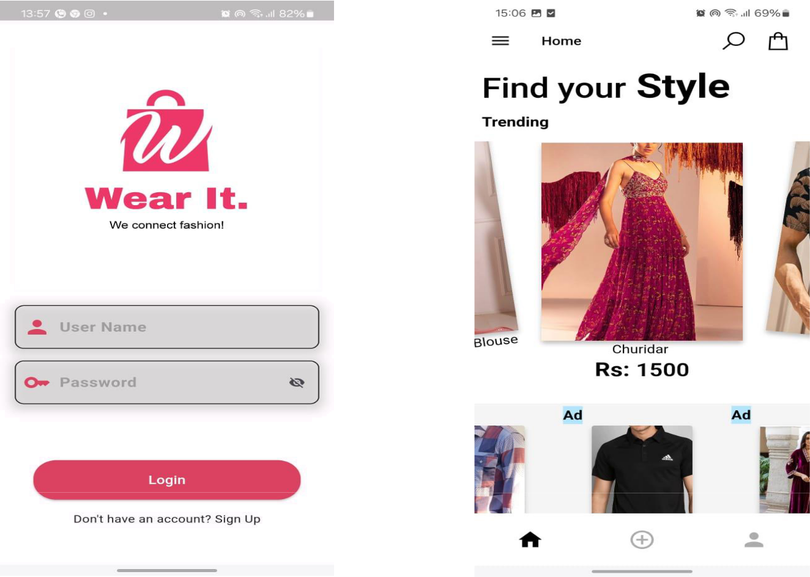
1. Login Page 2. Home Page

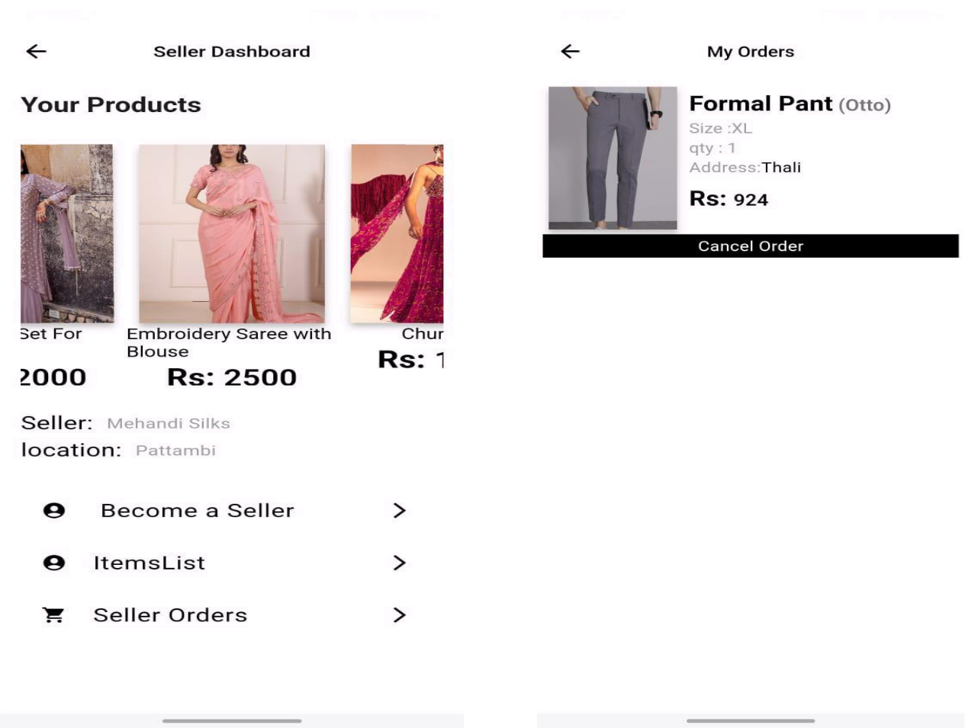
3. Seller Dashboard 4. My Orders

5. Payment
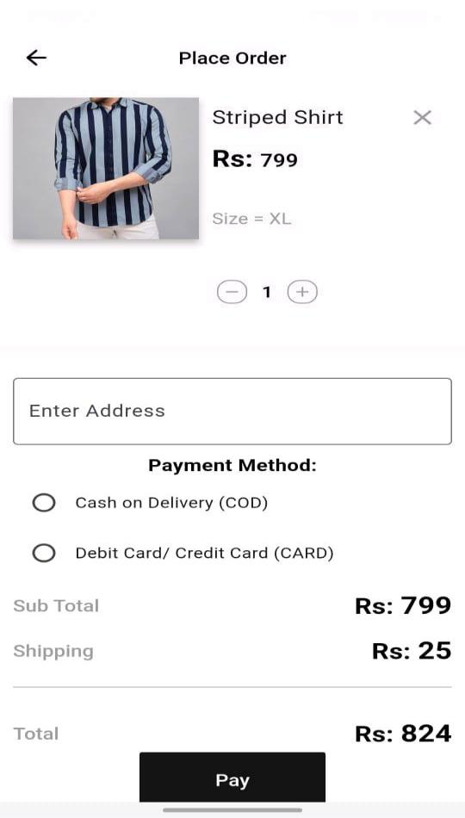

7. CONCLUSION

Our solution offers a unique and Innovative platform for clothing stores to reach a wider Audience and complete in the E-commerce industry .With the rise of Online shopping, it is crucial for clothing stores top adapt and embrace new technologies. E-commerce app typically summarizes key points such as the app’s features, benefits to users potentials for growth and any future developments or enhancements planned. It might also express gratitude to users for their support and feedbacks, and encourage continued engagement with the app. Our conclusion aims to revolutionize the e-commerce industry and bring together clothing stored and online retailing.

8. SCOPE OF FUTURE WORK

In the scope of future work for our clothing e-commerce app, we aim to prioritize several key areas for enhancement. Firstly, personalization features will be refined through advanced algorithms to offer tailored product recommendations and integrate virtual try-on technology for improved visualization. Secondly, we plan to integrate augmented reality (AR) to facilitate virtual fitting experiences, reducing returns and bolstering customer satisfaction. Thirdly, a robust size and fit recommendation system will be developed, leveraging machine learning to suggest optimal sizes based on user data. Additionally, social commerce integration will enhance engagement by enabling seamless sharing of purchases and influencer collaborations. Subscription services will be explored, offering curated clothing items on a regular basis. AI-powered chat bots will provide real-time support and streamline the purchasing process. Visual search functionality will be implemented to allow users to find similar products through image uploads. Sustainability initiatives will be incorporated, promoting eco-friendly options and educating users about product environmental impact. Offline integration will bridge online and in-store experiences, while localization efforts will expand our reach to diverse markets. Furthermore, analytics tools will be utilized to gather insights for continuous improvement, ensuring agility and responsiveness to evolving market dynamics and user preferences.

9. BIBLIOGRAPHY

- IEEE-2016-“Developing a Ecommerce Website” , Authors: Syed Emdad Ullah,Tania Alauddin
- IEEE- 2019-“The Application of E-Commerce on Fashion Shop”, Author : Jonathan, Andrikurniwan
- IEEE-2021-“Cloud Computing and E-Commerce Based Entrepreneurship”, Author : Satender Singh
- IEEE-2010-“Study on the Typical application of E-commerce “,Author: Wang Li
- Principles of Software Engineering – Author : Roger.S.Pressman-7th Edition.

